How To Print in Color

- Make sure the appropriate printer in selected (1). Scroll down and select “more settings” (2).

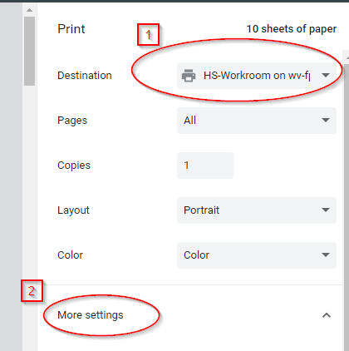

- At the bottom of “More Settings”, select “Print Using System Dialog…(Ctrl+Shift+P)”.
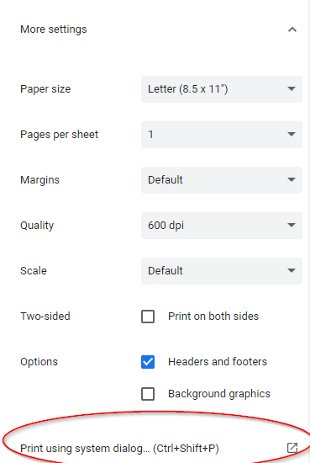

3. Next, make sure the appropriate printer is selected (1) and choose “Preferences” (2).
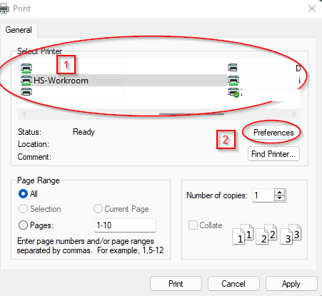

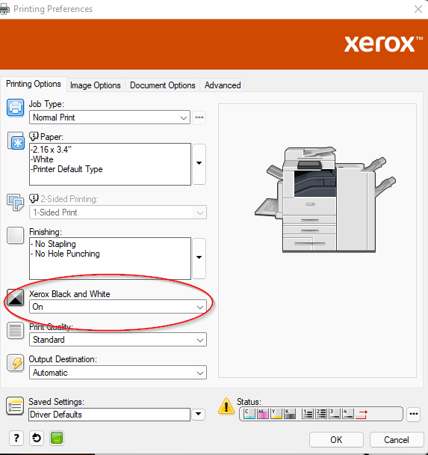
4. Once inside “Preferences”, go to Xerox Black and White (shown below) and use the drop-down menu to reflect “Off”, then click OK.

5. Next select “Print”. This will prompt another dialog box where you will enter your color copy code in the User ID spot. You will then select OK and your document will be printed. If you do not know your color copy code, please see your Technology Director.

